Marriage Essentials
The Top 9½ Marriage Busters
How to avoid them and build a lasting, fruitful marriage
Buster No. 7: Dollar Drama
Part 4 –Money tendencies (continued) and money classrooms
Paul and Teri Reisser – March 10, 2024

Recap from Parts 1, 2 and 3 – See previous handouts

Some basic principles:
- God owns it all.
- The Bible has a lot to say about money – an estimated 2,000 verses deal in one way or another with finances.

Some specific observations about money and marriage:
- Money involves, touches, and pulls on just about every area of life and marriage. It is thus very important (but sadly uncommon) for husbands and wives to understand their own -- and their spouse’s -- emotions and attitudes about money. Doing so promotes “knowing and being known,” which in turn leads to compassion for the other person’s concerns and (inevitable) mistakes in this area. Your concepts about money originate from:
  - Your family of origin – what was normal in terms of resources and attitudes
  - Your self-concept – sense of competence, safety, value
  - Your values – what your spirituality/morality dictates
- Husbands and wives will always have differences of opinions, attitude, and understanding about how their money should be made and spent, just as they will have differences of opinion about work, raising children, other family members, etc. However, these differences can complement each other, and if handled correctly can help both of you grow in this area.

Some common tendencies, themes and variations in these differences:
- Common differences between men and women regarding money:
  - Men – money is often a way of “keeping score.” (“Am I a success?”)
  - Women – money is often tied to their sense of security.

- In The Five Money Personalities, Taylor and Megan Kovar describe the following distinct ways of thinking about and dealing with money. (We reviewed these in detail on February 11, 2024 – see that handout.) They are:
- Savers
- Security seekers
- Spenders
- Risk takers
- Flyers

- In her book Know Yourself, Know Your Money (Ramsey Press, 2020), Rachel Cruze (daughter of Dave Ramsey) describes seven money tendencies that she has observed in conversations with thousands of people over the past decade. We adapted the following material from her book, with a few additions and comments of our own.
Before we list them, a few notes:
  - Each of these tendencies represents a spectrum of attitude and behavior toward handling money – or to use another phrase, “how we are wired.”
  - None of these are “good” or “bad” as such, though extremes of any tendency can lead to conflict or even chaos.
  - Also, none of these are “either” / “or” categories. We may lean one way in one situation and the other way in a different situation. We may also shift on a particular spectrum with the passage of time.
  - These tendencies may arise from genetics, our unique personalities, experiences early or later in life, our commitments (or lack thereof) to God and others, and so on.
  - We will point out some overlays and overlaps between the five money personalities described by Taylor and Megan Kovar in their book (The Five Money Personalities, which we reviewed on February 11) and the seven money tendencies outlined by Rachel Cruze in hers.
  - What’s the point of looking at this? Understanding our own money tendencies, and that of our spouse, can improve communication and cooperation in managing finances and making progress toward goals in this important arena.
  - Bottom line: Study your partner! Be curious. Never assume you know everything about him or her. And don’t assume that what you think you understand now will never change. It will! (In 2009, Paul and Teri wrote an entire book about this: Your Spouse Isn’t the Person You Married.)

Last time we looked at:
- Saver or spender
- Nerd or free spirit
- Experiences or things
- Quality or quantity

Today we continue with:
- Safety or status
Basic question: Do you see money as providing safety and peace of mind, or as a way of keeping score, a measure of personal achievement? Note: The safety tendency has a lot of similarities to the security seeker personality, and the status tendency may include some characteristics of the risk taker personality.

Positive aspects of the safety tendency: You are more likely to…
- Be careful and intentional about your use of money, in order to be able (as much as humanly possible) to deal with whatever curve balls life throws at you.
- Have a budget and know you can cover your expenses.
- Build an emergency fund of 3 to 6 months of expenses in case you lose your job or other source of income.
- Think through the potential consequences and risks of your decisions and thus act prudently.
- Purchase and maintain insurance to cover potential losses: life, health, home, auto, long-term care, liability.

Potentially negative aspects of the safety tendency:
- You are more likely to make decisions based on fear and risk reduction than on other worthwhile considerations.
- You may over-insure yourself. You really don’t need to buy that extra (and usually not cost-effective) insurance to protect your various purchases, or insurance for elephant stampedes, lightning strikes or alien abductions.
- You may find yourself leaning more on your finances and insurance for peace of mind, rather than on God.

Positive aspects of the status tendency:
- You may see your financial achievement as an asset to manage responsibly and a resource to bless others.
- In this regard, you may be in a position to support ministries and worthwhile projects at a level that would not be possible with lesser resources.

Potentially negative aspects of the status tendency: You are at risk for…
- Basing your worth and identity on your financial statement.
- Surrounding yourself with expensive stuff and purchasing lavish experiences as proof of your success.
- Shifting from intentionality regarding your definition of success to absorbing what other people, and the culture at large, think and say about it. (In other words, “…spending what you don’t have, to buy what you don’t want, to impress people you don’t care about.”)
- Cultivating smugness and pride over your financial accomplishments, and lowering your resistance to looking down on those who have not done as well in this area.

“The truth is that money is just a magnifying glass: It makes you more of whoever you are. If you are kind and generous, you’ll be even more kind and generous with money. If you are rude and self-centered, you’ll be even more rude and self-centered with money. Money is just a tool and has nothing to do with your identity.” (Rachel Cruze, Know Yourself, Know Your Money, pp. 53-54.)

- Abundance or scarcity
This is the glass-half-full vs. glass-half-empty dichotomy. The person with the abundance tendency believes there will be more opportunities, more options and more money, and in the face of challenges believes “It will all work out.” He or she shares much in common with the risk-taker personality. The person with the scarcity tendency makes decisions based on a mindset that resources are limited (or likely to decrease), and makes decisions accordingly. He or she has some characteristics that overlap with the security-seeker personality.

Positive aspects of the abundance tendency:
- You are willing to do things others might not do, and to take risks.
- You have a high tolerance for change.
- You tend to be more generous, believing that there will always be ways to make more money.

Potentially negative aspects of the abundance tendency:
- Your optimism – which can also feel like big faith in God -- may overtake wisdom (including biblical wisdom) in making financial decisions.
- You may not count the cost(s) of a financial decision before you proceed.

Positive aspects of the scarcity tendency:
- You tend to play it safe with money.
- You are at less risk for being wasteful with money, since you see it as a limited resource.
- You are more likely to prepare and count the cost before making a financial decision.
- You may be more objective and realistic about financial opportunities.

Potentially negative aspects of the scarcity tendency:
- Your scarcity mindset may include a belief that God can’t or won’t provide, and that there are limits to His goodness or ability.
- Like the person with a safety tendency, you may make financial decisions (including avoiding opportunities that might move your life forward) based more on fear than facts.
- You may have difficulty giving away things you no longer use or need because you “might” need one or more of them someday. You are thus at risk for living in a cluttered (and usually disorganized) environment. Note: Hoarding, which would appear to be an extreme form of this tendency, is in fact a mental disorder that is extremely resistant to change.
- You may also be reluctant to follow biblical directives to share your financial resources because of fear that you may be caught short in the future.

- Spontaneous giving or planned giving
Do you give spontaneously, in the moment, or do you plan most or all of your giving?

Positive aspects of the spontaneous giving tendency:
- You feel free to respond to a need on the spot, with both heart and open hand.
- You are able to experience both the joy of the recipient and your own joy in meeting a need and seeing his or her response.
- You are duplicating, in your own way, a pattern in Jesus’ life of stopping to help people while on his way to another destination. (See, for example, his healing the woman who touched him while he was on his way to see Jairus’ critically ill daughter. Mark 5:24-34)

Potentially negative aspects of the spontaneous giving tendency:
- If you haven’t done some (or any) homework on the destination of your spontaneous gift, you may send your money in a direction that is ineffective.
- Making a substantial spontaneous gift without consulting your spouse could potentially torpedo your budget and cause unnecessary turbulence at home.

Positive aspects of the planned giving tendency:
- You take your resources, and where they will be directed, very seriously.
- You avoid giving to individuals or organizations you haven’t researched.
- Once you have decided to donate, you are likely to stay committed to supporting that person or organization, though you also reserve the right to review the effectiveness of their work.

Potentially negative aspects of the planned giving tendency:
- You may miss opportunities to bless someone with an immediate need, and in so doing ignore a nudge from God.
- You can become frustrated with and critical of a spouse who makes spontaneous donations to people or causes you feel are unworthy of your support.
- Likewise, a spontaneous giver spouse may be annoyed or disappointed when you stick to your planned giving guns and bypass someone in need. (“Bah, humbug, Mr. Scrooge…”)

As noted with these money tendencies, there is no right or wrong here. Rachel Cruze’s approach to spontaneous vs. planned giving – and we second the motion -- is to do some of each. By all means talk about, research, plan for and budget your giving – and in your budget include an agreed-upon amount for spontaneous giving.

Table Discussion:
- Introduce yourselves. How long married, kids, work, dogs and cats, etc.
- Looking at the safety/status, abundance/scarcity and the spontaneous/planned giving tendencies, where do feel you land on each of these?
- How similar or different are you and your spouse on each of these tendencies?
- How have your similarities or differences in these three areas affected your handling of money, and your marriage in general?

Money classrooms: – What you learned about money as you were growing up.

A quote from Rachel Cruze:
Your childhood household was your money classroom. As an adult, you may handle money much like your parents did when you were a child, are you may have deliberately chosen to modify -- or do the exact opposite of -- what your parents did. Regardless, we each learned lessons there that we’ve taken into adulthood. Some are good habits and healthy views on money that help us. And some our lessons we wish we could unlearn.
(Know Yourself, Know Your Money, p. 12)

Cruze describes four basic money classrooms, based on two variables:
Stressed vs. calm environments related to finances
Closed vs. open communication about money.

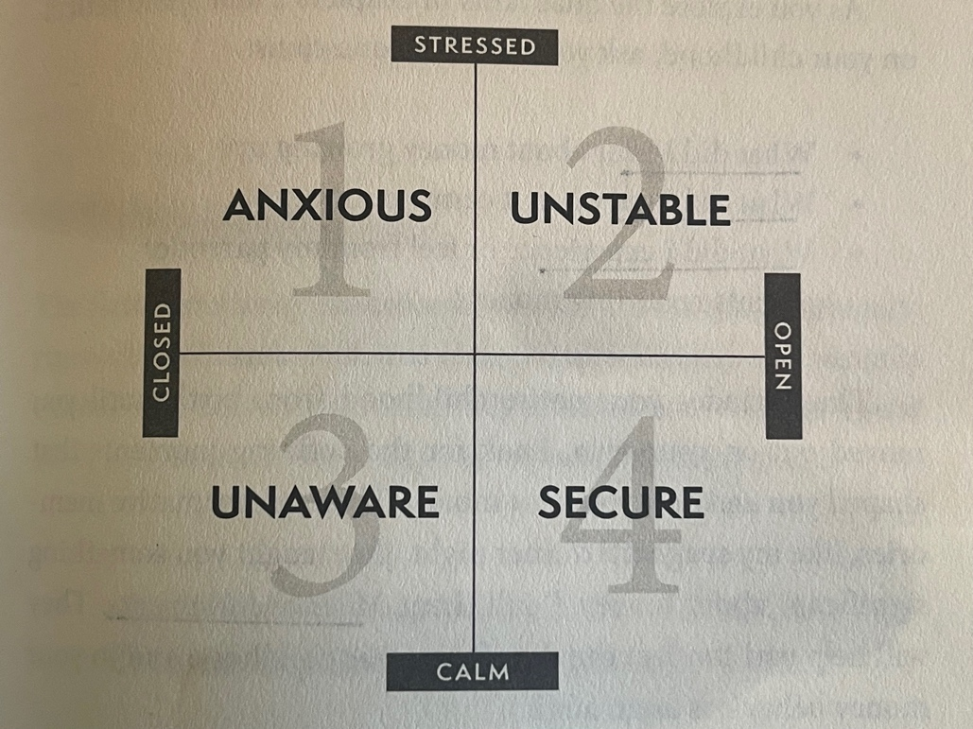

As we describe these four classrooms, reflect on your life, from childhood until moving out and living on your own:
- What did I hear about money growing up?
- What did I see regarding money?
- What did I experience and feel regarding money, whether from one or both parents or others who played a significant role in my life?

- The anxious classroom: Emotionally stressed and verbally closed. A lot of tension regarding money, but little discussion about it.
Challenges you may face after growing up here:
        - You may have a hard time talking about money.
        - You may have a lot of fear about lack of money.
        - You may resent your parents or others who raised you in this environment.
Strategies to counter these challenges:
- Initiate conversations with your spouse, or a trusted family member of friend, about money, even if doing so is hard. Tell the other person(s) why this is hard for you.
- Work on a detailed monthly plan for your money. This builds confidence and removes the sense of the unknown, which so effectively drives fear.
- Extend grace toward your parents or others who created this classroom. Consider what may have happened to them when they were growing up. (For example, was money a taboo topic in their home?) Did they think they were protecting you by not talking about money? The object would be to avoid making excuses, sweeping their mistakes/faults under the rug, or harboring bitterness toward them. Rather, discern the truth and show grace.

- The unstable classroom: Emotionally stressed / unstable, and verbally open. A lot of emotion (usually tension) regarding money and a lot of arguments about it, public and private. Note: Sometimes the emotions expressed could be positive, but not necessarily healthy. (“We got a refund from the IRS! Let’s go have a night on the town!”) Financial “mood swings” could lead to feelings of instability and insecurity.
Challenges you may face after growing up here:
- You may believe that there is no such thing as a healthy conflict, or a healthy way to resolve one. You expect discussions about money to be emotionally charged.
- You may have become fearful, apathetic or passive about discussing money. (“What’s the use? We’ll just end up fighting” or “Do whatever you want / think is best,” for example.)
Strategies to counter these challenges: (Hint: This isn’t just about money.)
- As with the anxious classroom, initiate conversations about money rather than withdrawing from them. If these result in unhealthy arguments with your spouse, do some reading (there are plenty of good books dealing with marital conflict), reach out to trusted and mature friends, and/or get counseling in order to learn how to address conflict in a healthy way.
- Also, as with the anxious classroom, work on a detailed monthly plan for your money, and strive to adhere to it. This can build cooperation and teamwork, and (if both of you abide by it) reduce disagreements and tension.

- The unaware classroom: Emotionally calm and verbally closed. Everything seemed to be fine, you didn’t know about your parents’ money situation and you didn’t have to worry about it.
Challenges you may face after growing up here:
- Since you didn’t have to pay attention to finances growing up, you may enter adulthood unaware, uneducated and untrained in this area. You never needed a budget growing up, so why worry about one now? If you have married someone who is financially attentive and responsible, good for you – but continuing your blissful ignorance can lead to serious conflict.
- If and when your lack of attention and knowledge leads to a financial crisis, which is virtually inevitable, you may feel betrayed and angry with your parents for not better preparing you for adult responsibilities.
- You may also feel betrayed if you discover that your parents’ apparent financial health was in fact an illusion. If you find out that they are in financial trouble, you may feel it is your responsibility to bail them out (assuming you have the resources to do so).
- You may feel compelled to avoid conflict at all cost, and thus may not initiate or engage in hard conversations you need to have with your spouse. (Note: the rules are different for someone in an abusive relationship, where establishing safety, through whatever means necessary, is the priority.)

Strategies to counter these challenges:
- You can’t live in blissful ignorance anymore. Roll up your sleeves, put on your grown-up pants, stop ignoring financial concerns and instead join with your spouse in managing your money.
- As with the anxious classroom, extend grace toward parents who didn’t do this perfectly. Perhaps they grew up with a lot of dollar drama and didn’t want you to experience it.
- Think carefully before assuming responsibility for one or more parent’s financial health (especially bailing them out or paying off their debts). Note – this is not the same as assuming power of attorney for their finances, which may be necessary if they are incapable of managing them.
- Break the “verbally closed” cycle and talk openly about your financial decisions with your kids (in age-appropriate conversations, of course).

- The secure classroom: Emotionally calm and verbally open, the ideal money classroom. Money is managed well, financial stress is absent or minimal, and money is discussed frequently and openly. You witnessed calm, intentional decision-making processes regarding money. There was respect and connection between your parents. Note: This can occur despite not having a lot of money – but limited resources are managed well.
Challenges you may face after growing up here:
- You may underestimate what it takes to pull this off: A lot of conversations (not all of them easy), a lot of focus and discipline, and some difficult or even painful decisions to stay the course.
- You may also underestimate the amount of time it takes to attain the standard of living that your parents most likely achieved.
- You may marry someone who has come from a very different money classroom, and who thus has very different financial habits.
Strategies to counter these challenges:
- Do what your parents modeled, while maintaining realistic expectations. Financial health is a marathon, not a sprint.
- Be patient and maintain respectful, gracious conversations with a spouse who struggles in this area.
- Pass the baton to your kids by discussing money matters with them regularly and teaching them skills they will need to become responsible, productive adults.

Table discussion:
- In which money classroom were you raised?
- How have my money classroom and my spouse’s money classroom interacted and impacted the way we manage finances?
- If you have kids at home, what steps have you taken / might take / will take to create a secure money classroom for them? (If they’ve left the nest, how do you think you did with this?)

A few final thoughts on managing money well as a couple

Managing money well as a couple – like so many other aspects of marriage – is a process of intentionality, learning from mistakes and extending grace. It requires engaging all of the skills that we talk about in our Marriage Essentials sessions:
  - Open communication.
  - Dealing with differences of opinion.
  - Avoiding the “Four Horsemen of the Apocalypse” that destroy marriages.
  - Serving the other person.
  - Confession, apology and extending forgiveness when mistakes are made.
  - Teaching and modeling behavior for children. (Give, save, spend.)
  - Working together on the details:
    - Husband and wife need to be thinking in terms of our money, not “yours and mine.”
    - Husband and wife need to know what money is coming in, and where it is going.
    - Who decides how money should be spent? Answer: Both of them.
  - Because surprises and emergencies in life are inevitable, they should try to put aside some money for an emergency fund.

Some productive homework related to money and your marriage:

Discussion question: Without casting blame, what do you think stops you from being able to discuss money issues as a couple?

- If you haven’t been through Financial Peace University, strongly consider doing so. This is a nine-week course that can be done online for $79.99, or for $99.99 with a lot of extra stuff. Check it out at ramseysolutions.com, or Google “Financial Peace University.”

- Review / meditate on / marinate in the contents of the handout: “A Selection of Bible Verses Dealing with Money-Related Topics.”

- We highly recommend that you set a time with each other to talk about finances in your marriage and family. Review the topics we’ve listed under “managing money well as a couple.” Go item by item and ask yourselves: “Are we doing well on this one, or could we use some work?” And if you both agree that there’s some room for work/improvement, what would be the first/next steps to make that happen?

Upcoming Marriage Essentials dates: March 24, April 7 and 21, May 5 and 19, June 9 and 23.

